MA 322 (2021) Scientific Computing Lab Lab 05

**Name:** Udandarao Sai Sandeep

**Roll Number:** 180123063

**Dept.:** Mathematics and Computing

**Q1.**

**Gaussian Quadrature with n = 2** (**Three point**) was followed to estimate the integrals. The following procedure was used:

1. A **polynomial P(x) of degree 3** was constructed (Legendre polynomial).
2. Then, the roots of the polynomial were considered as the nodes.

**Roots = $[ \frac{-\sqrt{3}}{\sqrt{5}} , 0 , \frac{\sqrt{3}}{\sqrt{5}} ]$**

1. Then, all the individual weights were found out using the formula:



1. Required Estimate = **Gn(f) = w0f(x0) + w1f(x1) + ………. + wnf(xn)**

Note: Since estimation with Legendre polynomials works best in the range **[-1,1]**, hence the x was substituted accordingly so that the range of integration becomes **[-1,1]**. For example, in part (a), **x was substituted with $\frac{y+5}{4}$** .

The results are as follows:

**Part (a)**

Estimated Value (with n = 2): **0.192259377256879**

Actual Value of Integral: 0.192259357732796

Error in the estimation: 1.9524082989219593 x **10-8**

**Part (b)**

Estimated Value (with n = 2): **-0.1768200178862206**

Actual Value of Integral: -0.176820020121789

Error in the estimation: 2.2355683970687323 x **10-9**

**Part (c)**

Estimated Value (with n = 2): **0.08875385361785668**

Actual Value of Integral: 0.08875528443525664

Error in the estimation: 1.4308173999638685 x **10-6**

We can see that the Gaussian quadrature predicts the integral correctly with great accuracy.

**Q2.**

Yes, such a function can be constructed.

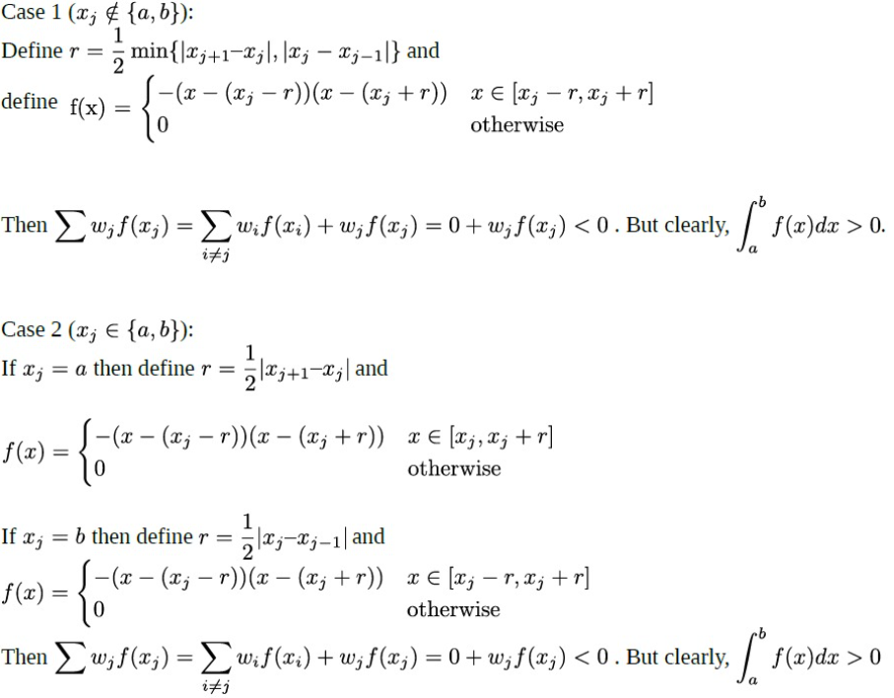

This shows that improper choice of weights may result in huge disparities.

**Q3.**

Here, the two-point Gaussian Quadrature (n=1) was applied to estimate the integral.

Then, Simpson’s Rule and Trapezoidal Rule was appropriately applied. The results are as follows:

**Estimated Value through Gaussian Quadrature (two-point): 1.0909090909126549**

Actual Value of Integral: 1.09861228866811

Error in the estimation: 0.007703197755455138

**Estimated Value through Trapezoidal rule: 1.3333333333333333**

Actual Value of Integral: 1.09861228866811

Error in the estimation: 0.23472104466522326

**Estimated Value through Simpson's rule: 1.1111111111111112**

Actual Value of Integral: 1.09861228866811

Error in the estimation: 0.012498822443001156

This shows that Gaussian Quadrature Formula is a **better** estimator than Simpson’s Rule and Trapezoidal Rule.

**Q4.**

Here, the similar procedure was followed to estimate the integral **(Gaussian Quadrature with n=2).**

**Estimated Value through Gaussian Quadrature (three-point): 0.6931216931216931**

Actual Value of Integral: 0.6931471805599453

Error in the estimation: 2.54874382521475e **x 10-5**

The following formula was used for Simpson’s one third rule. (with h = 0.125)



Estimated Value through Simpson's 1/3 rule:

0.6931545306545307

Actual Value of Integral: 0.6931471805599453

Error in the estimation: 7.350094585412137e **x 10-6**

Here, we can see that the error value in both cases is comparable. It is important to note that in Simpson’s Rule, **n = 8**, but in the case of Gaussian Quadrature, **n = 2**.

**Q5.**

**First Method:**

The values of $a$, $b$ and $c$ have been calculated

(using sample functions 1, x, and x2 (of degree < 3):

**a = 0.1666666666666666**

**b = 0.6666666666666666**

**c = 0.1666666666666666**

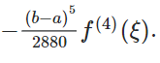

Error Bound for **first** method = 0.00034722222222222224max|f⁴(x)|

**Second Method:**

The values of $α,$ $β$ and $γ$ have been calculated

(using sample functions 1, x, and x2 (of degree < 3):

$α$**= 0.6666666666666666**

$β$**= -0.333333333333333**

$γ$**= 0.6666666666666666**

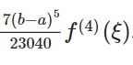

Error Bound for **second** method = 0.00030381944444444445max|f⁴(x)|

By observing the values of error, the error for **second** method is lesser for same value of $ξ.$ So, the second method has a lower bound for maximum error.

**Q6.**

All values have been rounded up to 2 decimal places.

**Estimated Value through Gaussian Quadrature (n = 1): -0.76**

Actual Value of Integral: -0.915

**Error in the estimation: 0.16**

**Estimated Value through Gaussian Quadrature (n = 2): -0.838**

Actual Value of Integral: -0.915

**Error in the estimation: 0.08**

**Estimated Value through Gaussian Quadrature (n = 3): -0.867**

Actual Value of Integral: -0.915

**Error in the estimation: 0.05**

**Estimated Value through Gaussian Quadrature (n = 4): -0.883**

Actual Value of Integral: -0.915

**Error in the estimation: 0.03**

**Estimated Value through Gaussian Quadrature (n = 5): -0.892**

Actual Value of Integral: -0.915

**Error in the estimation: 0.02**

­

We can see that Error **decreases** with **increase** in the value of **n**.